Technical Design Document for

Online Retirement Application

Prepared for

**Office of ORA**

Date:

10/5/2018

Version 1.0 Draft

**Prepared by**

**Donovan Goode – Business Applications Technology Solutions Professional**

**Contributors**

Revision and Signoff Sheet

Change Record

|  |  |  |  |
| --- | --- | --- | --- |
| Date | Author | Version | Change Reference |
|  |  |  |  |
|  |  |  |  |
|  |  |  |  |
|  |  |  |  |

Reviewers

|  |  |  |  |
| --- | --- | --- | --- |
| Name | Version Approved | Position | Date |
| Patrick McGowen |  |  |  |
| Chris Geer |  |  |  |
|  |  |  |  |

Table of Contents

Purpose and Scope 6

Abbreviations and Glossary of Technical Terms 7

Assumptions and Constraints 7

1 Solution Overview 8

2 Environment Constraints and Assumptions 9

3 Dynamics Portal Application DevelORAent 10

3.1 Portal Application Object Model 11

3.2 ORA Website/Webpage Architecture 13

3.2.1 Web Template Design 14

3.2.2 Custom Page/Web Templates: 16

Agency Services 16

Applicant Summary of Service 16

HR Services 16

Online Retirement Application 16

ORA Home Page Slider 16

ORA Home 16

Payroll Checklist and Certification 16

Payroll Services 16

Summary of Service Employee Create 16

3.3 ORA Web Forms and Design 16

3.3.1 Retirement Application: 18

3.3.2 Applicant Summary of Service Certification 19

3.3.3 Payroll Checklist and Certification 20

3.4 ORA Entity Forms 21

3.4.1 Agency Account Admin Create Contact for Invitation 21

3.4.2 Agency Account Management 21

3.4.3 Agency Admin Create Retirement Package 21

3.4.4 Agency Admin Summary of Service Create 21

3.4.5 Agency Admin View Employee Record 21

3.4.6 Agency HR Checklist 21

3.4.7 Applicant Certified Summary of Service Review 21

3.4.8 Applicant Summary of Service Review Read Only 21

3.4.9 Complete HR Checklist 21

3.4.10 Payroll Checklist 21

3.4.11 Payroll Package Review 21

3.4.12 Review Entire ORA 21

3.4.13 Service History Edit 21

3.4.14 Supporting Document Upload 21

3.5 ORA Entity Lists 22

3.5.1 Agency Admin Agencies 22

3.5.2 Agency Admin Agency Contacts 22

3.5.3 Agency Contacts 22

3.5.4 Agency Applicants’ Retirement Applications 22

3.5.5 HR Applicant Packages 22

3.5.6 Online Retirement Applications 22

3.5.7 Online Retirement Applications – Certify Summary of Service 22

3.5.8 Payroll Applicant Packages 22

3.5.9 Payroll Services Retirement Applications 22

## Purpose and Scope

The purpose of this document is to outline the technical design for the ORA System. The PoC demonstrates how to achieve the ORA requirements utilizing the Microsoft Dynamics 365 platform.

The purpose of this document can be summarized as follows:

* It describes the high-level technical design
* It describes the system configurations and customizations used in the designs
* It has been an input to the functional tests for the solution
* It can be used to support future develORAent and enhancements

The document also describes the security model, entity data model along with the associated logical components designed and developed to meet the requirements gathered by the Microsoft Team when demonstrating the prototypes.

The intended audience for this document is:

* Developer(s)
* Tester(s)
* Support team
* Architect(s)

The intended audience for this document should have a basic technical understanding of the Microsoft Dynamics 365 product.

## Abbreviations and Glossary of Technical Terms

|  |  |
| --- | --- |
| Abbreviation | Explanation |
| CRM | Customer Relationship Management |
| OOB | Out of the box |
| ORA | Online Retirement Application |
| SaaS | Software as a Service |

## Assumptions and Constraints

|  |  |  |
| --- | --- | --- |
| Sl. No. | Assumption/Constraint | Details |
|  |  |  |
|  |  |  |
|  |  |  |
|  |  |  |
|  |  |  |

1. Solution Overview

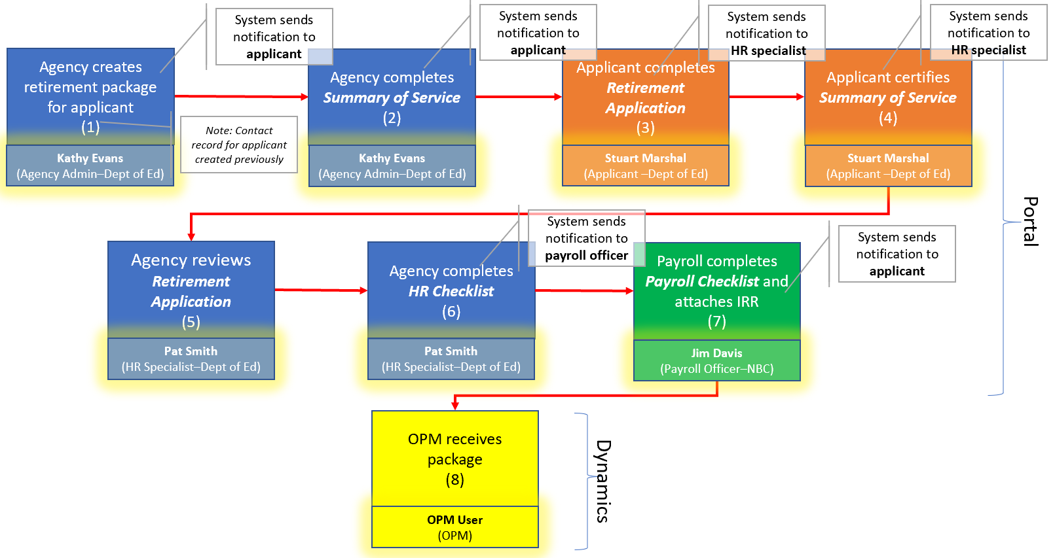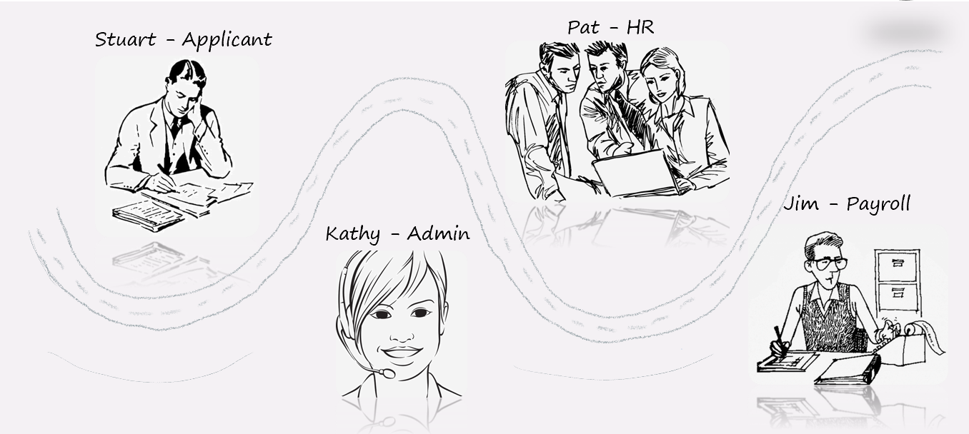

1. Environment Constraints and Assumptions

Dynamics 365 is a purchased and licensed product. The ORA Application is leveraging Dynamics 365 CE for GCC and a Dynamics 365 Portal.

1. Dynamics Portal Application Development

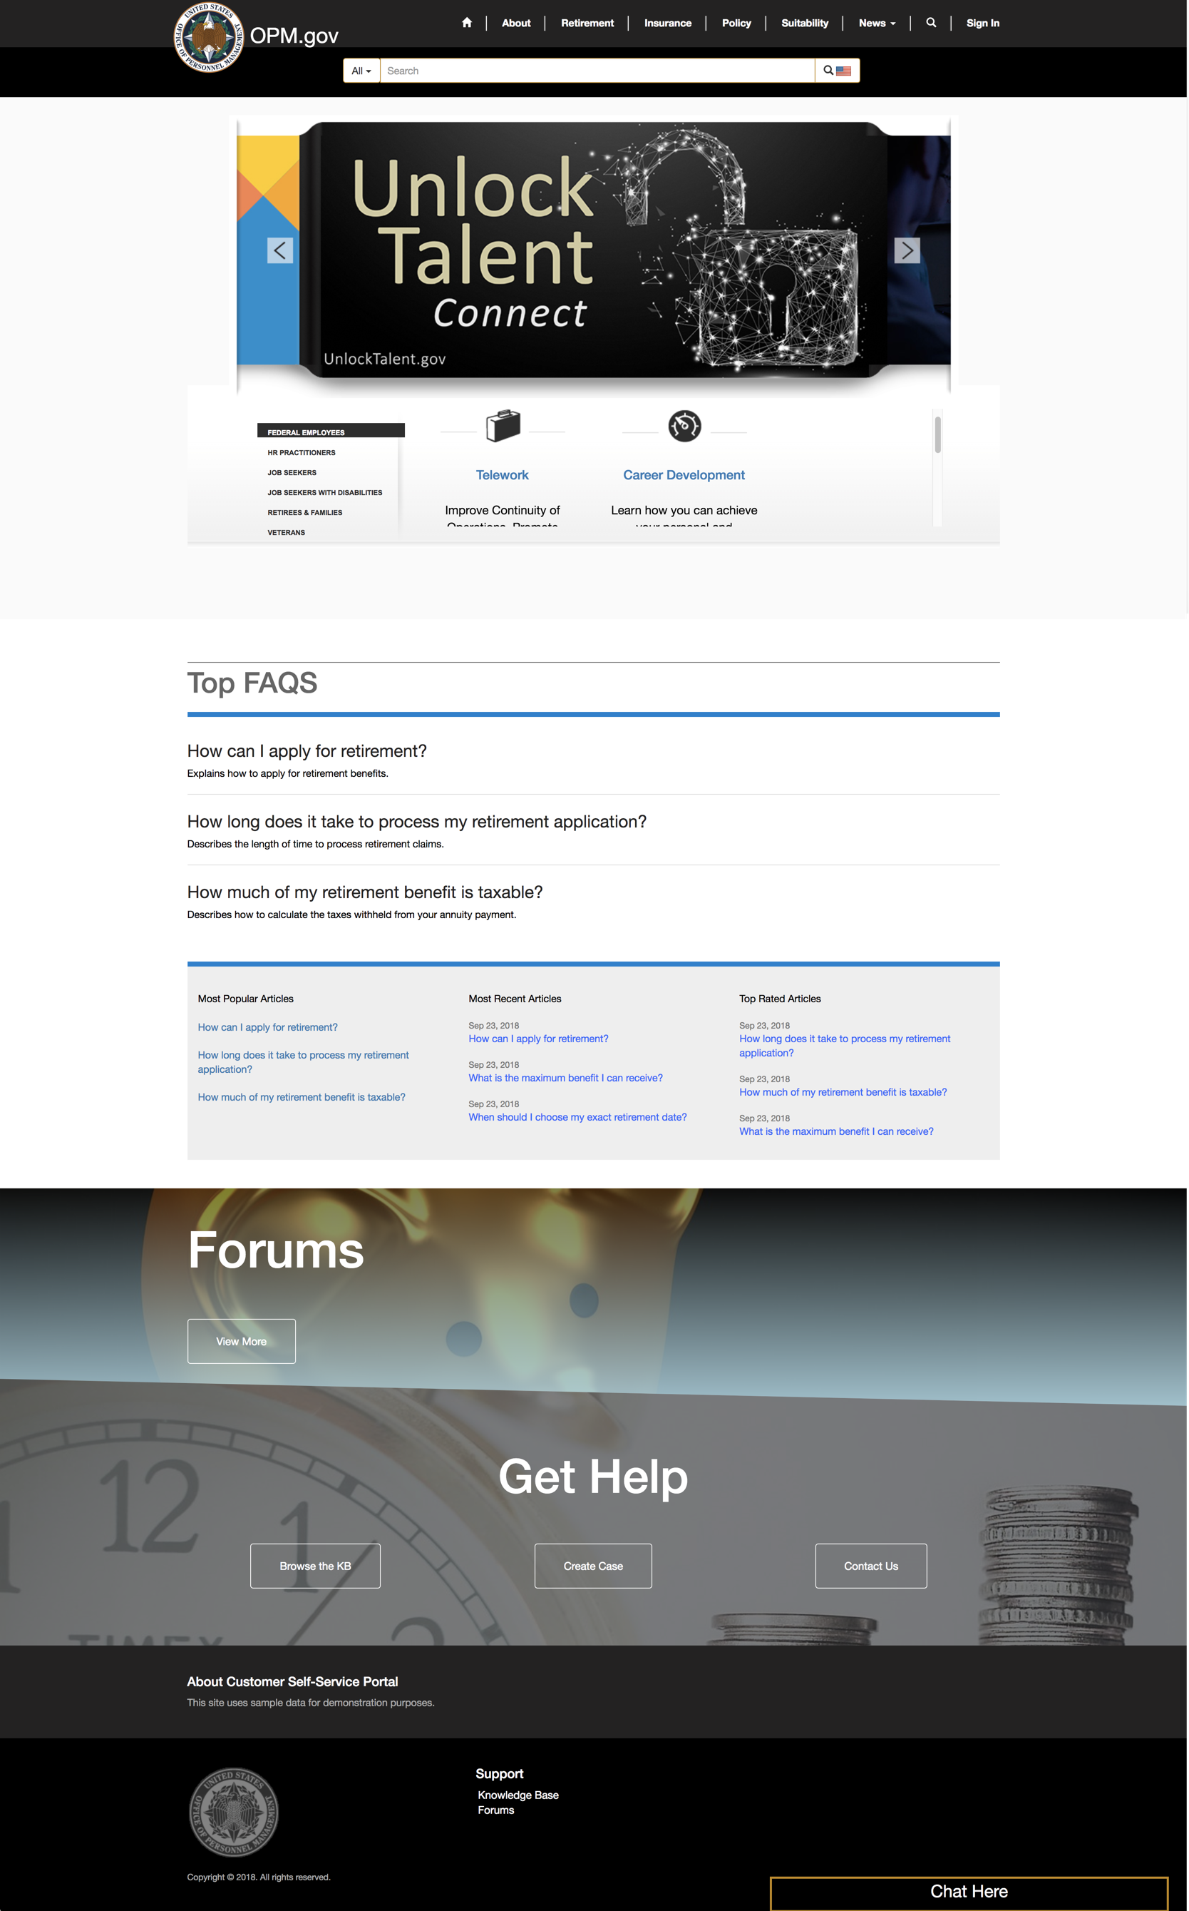



* 1. Portal Application Object Model



* **Portal Website:**
  + The portal site has a root page which is the home page. The homepage is the parent to all other webpages.
  + **Portal Web Page**
    - Portal Web pages must use a **Page Template**. These page templates can leverage either an out of the box custom rewrite URL or a web template.
      * Custom Rewrite URL
        + This is a custom .aspx webform
      * **Web Template**
        + This a web template created from the CRM backend and leverages the liquid language for liquid templating and rendering of objects.
    - Custom JavaScript can be embedded at the web page level or the webform and entity form levels
    - Portal webpages also have the option of surfacing the following dynamics 365 entity objects:
      * **Web Form**
        + Webforms are typically used when you want to have a multipage guided navigation wizard to collect user input in multiple steps. There are many advantages and disadvantages of using this. It depends on client needs or design needs.
        + Webforms leverage Dynamics CRM forms and fields of the various entities in the CRM backend
      * **Entity Form**
        + Entity forms are typically used to collect user input and information when you have a straightforward form that collects all information up front in a one step process
      * **Entity List**
        + Entity Lists leverage Dynamics CRM Entity Views. These are typically used to display a list of records related to a portal user or associated to an account.

General Webpage details configuration:

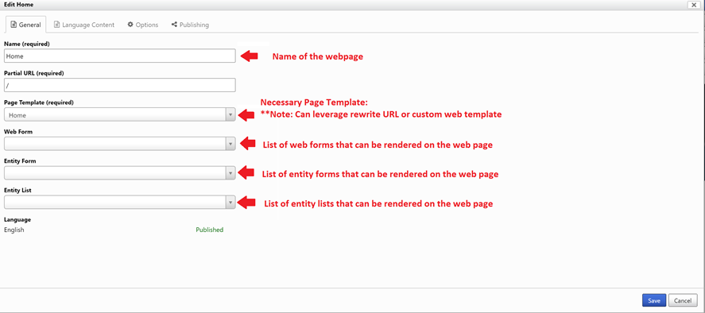

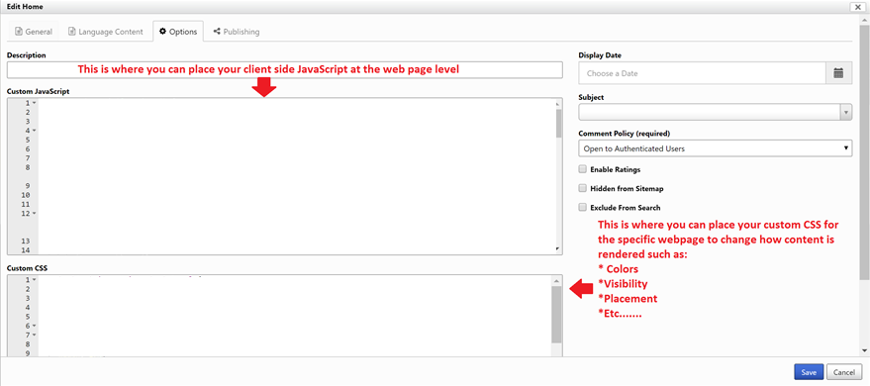

* 1. ORA Website/Webpage Architecture



The ORA system architecture can be observed in the image above. There are many different Parent-child relationships that exist in the design of this portal solution as observed.

**Home**

* Retirement
  + Online Retirement Application
    - Retirement Application
    - Applicant Certify Summary of Service
    - Review and Print Application
    - Online Retirement Submission Acknowledgment
    - Certify Summary of Service Acknowledgement
* Agency Services
  + Manage Agency
    - Employee Applicant Management
  + Agency Certified Summary of Service
* HR Services
  + HR Checklist
* Payroll Services
  + Payroll Checklist
    - ORA Submission Acknowledgement
    1. Web Template Design

The ORA solution leverages the benefits of being able to develop custom web templates, which bring truly rich and dynamic powerful customization capabilities to the portal.

Liquid is an open-source templating language for website design and is supported by Dynamics 365 Portals. (Version 8.X and later)

Liquid was originally written in Ruby, but has since been [ported to the .NET framework](http://dotliquidmarkup.org/), which in turn has made it easily adaptable for use with CRM portals. A significant amount of customization can be achieved by adding Liquid objects, tags, and filters to the content contained within a web template, web page, content snippet, or another record type.

The awesome thing about Liquid, is that it gives portal developers the ability to have server-side access to entity records in Dynamics CRM pre-load of a webpage. It basically gives you what’s in the database at the current context, so that you can leverage the client side to do what you need instead of always writing C# plugins in a more rapid manner.



* + 1. Custom Page/Web Templates:

### Agency Services

### Applicant Summary of Service

### HR Services

### Online Retirement Application

### ORA ORA Home Page Slider

### ORA Home

### Payroll Checklist and Certification

### Payroll Services

### Summary of Service Employee Create

* 1. ORA Web Forms and Design

Web Forms allow users to define entity forms and custom logic within the CRM to render data entry forms within Dynamics 365 Portals without the need for developer intervention. Web Forms support single step, multi-step navigation and branching logic. Web Forms are commonly used to produce a wizard like feel to guide users through a form to collect data in a more logical manner on the portal.

The Web Form contains relationships to web pages and a start step in order to control the initialization of the form within the portal. The relationship to Web Page allows dynamic retrieval of the form definition for a given page node within the website.

The other options on the Web Form record itself control top-level preferences for the multi-step process as a whole, for example whether or not you'd like to display a progress bar.

The Web Form Step provides the flow logic of the form’s user experience such as steps and conditional branching. It also provided details regarding the rendering of a form and additional behavior.

Each Web Form will be presented on the portal has one or more steps. These steps share some common properties, outlined below. Each Step contains a pointer (a lookup) to the next step, with the exception of terminal steps. Terminal steps do not have a next time, and are thus the last step of the Web Form (due to conditional branching, there can be multiple terminal steps)

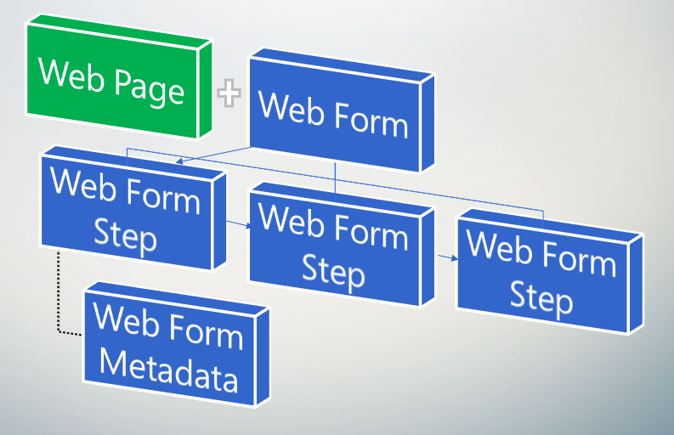

* + 1. Retirement Application:



* + 1. Applicant Summary of Service Certification



* + 1. Payroll Checklist and Certification



* 1. ORA Entity Forms
     1. Agency Account Admin Create Contact for Invitation
     2. Agency Account Management
     3. Agency Admin Create Retirement Package
     4. Agency Admin Summary of Service Create
     5. Agency Admin View Employee Record
     6. Agency HR Checklist
     7. Applicant Certified Summary of Service Review
     8. Applicant Summary of Service Review Read Only
     9. Complete HR Checklist
     10. Payroll Checklist
     11. Payroll Package Review
     12. Review Entire ORA
     13. Service History Edit
     14. Supporting Document Upload
  2. ORA Entity Lists
     1. Agency Admin Agencies
     2. Agency Admin Agency Contacts
     3. Agency Contacts
     4. Agency Applicants’ Retirement Applications
     5. HR Applicant Packages
     6. Online Retirement Applications
     7. Online Retirement Applications – Certify Summary of Service
     8. Payroll Applicant Packages
     9. Payroll Services Retirement Applications